Student Management System
System Design Documentation - Level 0 DFD
Document Type: | System Design - Data Flow Diagram
Version: | 1.0
Date: | 4/9/2026

1. Introduction
This document presents the Level 0 Data Flow Diagram (DFD) for the Student Management System. The Level 0 DFD, also known as a Context Diagram, provides a high-level overview of the entire system and its interaction with external entities. It serves as the foundation for understanding the system architecture and information flow.

2. Purpose
The primary purpose of this Level 0 DFD is to:
- Provide a system boundary by showing what is inside and outside the system
- Identify all external entities that interact with the system
- Show major data flows between the system and external entities
- Document labeled data exchanges for clear understanding

3. Level 0 Data Flow Diagram
The diagram below illustrates the complete context of the Student Management System with all external entities and data flows:
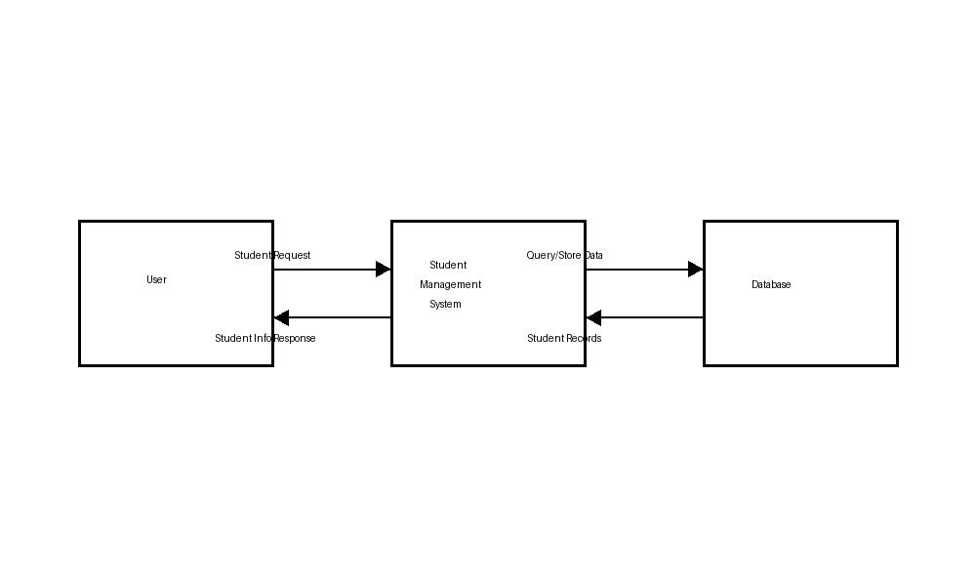

4. System Components

4.1 External Entities
Entity | Description
User | Any person (student, admin, staff) who interacts with the system to request or manage student information.
Database | Central repository for storing and retrieving all student-related data and records.

4.2 Central Process
Student Management System: The central process that handles all student-related operations including enrollment, record management, data validation, and communication between users and the database.

5. Data Flows
The following table describes all data flows in the system:

From | To | Data Flow Name | Description
User | System | Student Request | User sends requests for enrollment, records, or data updates.
System | User | Student Info Response | System returns processed student information and responses.
System | Database | Query/Store Data | System queries or stores student data in the database.
Database | System | Student Records | Database returns requested student records and information.

6. Key Points
- The system acts as a central hub facilitating communication between users and the database.
- All data flows are bidirectional, enabling both input and output of information.
- The system manages data integrity and validation before interacting with the database.
- Clear labeling of data flows enables stakeholders to understand system interactions at a glance.

7. Conclusion
The Level 0 Data Flow Diagram provides a comprehensive overview of the Student Management System architecture. This context diagram serves as a foundation for detailed system design and implementation. It clearly identifies the system boundaries, external entities, and major data flows, enabling stakeholders to understand how the system interacts with its environment.

